Plan: How to pace

In our handout, “Plan: What is pacing?” we explained what pacing is. In this handout, we will go into detail about how to make a plan to pace your energy. The first step to pacing is to understand how much energy you have for activities and tasks. We commonly use the term “energy envelope” to help people begin thinking about their energy.

What is your energy envelope?

Energy envelope is a term that describes the overall amount of energy you have available that you can use for different activities and tasks.

When recovering from post-viral fatigue, you may find that your energy envelope is smaller than it used to be.

To start using pacing to help you manage your energy envelope, you will need to start thinking about:
- How much energy you have in a day, and
- How much energy you need for different physical, mental, and emotional activities.

This might take some practice. Once you have spent some time pacing within your energy envelope, it will become easier for you to avoid post exertional malaise and the push/crash cycle. You can learn more about the push/crash cycle in our handout “Plan: What is pacing?”

There are many ways you can think about your energy envelope. Here are a few ideas to explore:
- Energy analogies
- Tracking your symptoms
- Listening to your body

Energy analogies

Using an analogy is one way to get a better understanding of your energy and how to best manage it. It can help you describe your energy by comparing it to the characteristics of a familiar item or idea. Energy analogies can also help you to communicate your energy limits and needs to others, particularly when you find an analogy that the other person can relate to.

BATTERY ANALOGY
You can use this analogy to help you understand the importance of building frequent rest breaks into your day to manage energy.
- Think about the energy you have as being represented by a battery
- The higher your battery percentage (e.g. 80%), the more energy you have for activity
- The more activities you do, the more battery power you will use
- You can recharge your battery with rest breaks. It can help to think of a comfortable chair or your bed as “re-charging” station.

BOWL OF MARBLES ANALOGY
This is a good visual analogy, and might be a good one for children or other members of your household to understand how much energy you have throughout the day.
- Think about your energy being represented by a bowl of marbles
- The more marbles you have in the bowl, the more energy you have to work with
- For every activity you do, remove one or more marbles from the bowl to represent the energy it takes to complete the activity

ENERGY BANK ACCOUNT ANALOGY
This analogy can help you manage your energy to avoid crashing, and the impacts of paying back energy debt.
- Think about money in your bank account representing the energy you can spend in a day
- The more money you have, the more energy you have
- When you do an activity it is like withdrawing money from the bank
- You can’t borrow from tomorrow (using more money than you have) without paying high interest fees in the form of post-exertional malaise

SPOON THEORY
The spoon theory is another commonly used analogy. It was developed by Christine Miserandino. https://me-pedia.org/wiki/Spoon_theory

Tracking your symptoms

Tracking (or logging) your symptoms is a way to see patterns in your activity, get a better understanding of what affects your energy, and what increases or reduces your symptoms.

Using a log can be useful, especially if you are experiencing delayed symptoms such as 2-3 days after an activity. You can personalize your tracker or log to best meet your needs.

When you start tracking your symptoms, you will want to think about the format that works best for you, and how you want to record your information.

HOW TO GET STARTED
- Choose your level of detail:
  - Big picture: Tracking your day overall and rating it at the end of the day. For example: “It was a good day. I paced by resting before and after a shower. My symptoms are mild.”
  - Detailed: Tracking specific activities, energy level, and symptoms, throughout the day. For example: “After making breakfast my energy fell and my symptoms increased. Midmorning I took a rest break and my symptoms decreased…”
- Choose your format:
  - Pen and paper in a day timer or calendar.
  - Digital: Using an app to track your activity and symptoms on your phone. Try searching ‘Symptom tracker’ in the app store or Google play store.
- Choose your own rating scale:
  - Numbers: You can rank your energy and/or symptoms using a number scale, such as a 1-3 or 1-5 or 1-10.
  - Descriptors: Low, medium, high, or cool, warm, hot.
  - Colours: You can rate your energy levels with red, yellow, green or use different symbols.
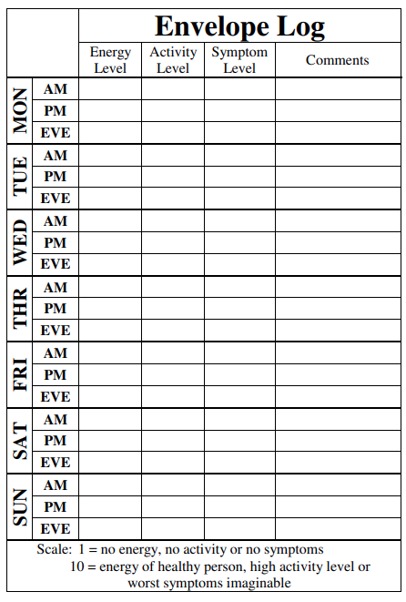
GETTING STARTED WITH A LOG
The envelope log is a good tracker to start with:
- It will allow you to see the connection between your energy, activity, and your symptoms
- Personalize it to suit your tracking need, e.g. you may wish to track multiple symptoms, such as fatigue, pain and brain fog
- Test it out for 2-3 weeks to see if it helps you to see patterns in your energy levels and symptoms

This log was created by Bruce Campbell. You can find out more about this log and other logs and tools at http://www.cfsselfhelp.org/library

Listening to your body

ACTIVITY TOLERANCE
You can try an activity tolerance log to manage your energy and symptoms. The activity tolerance log can help you to figure out how long you can do an activity safely, without increasing symptoms.

- Choose a specific activity, one you can break up into smaller tasks (e.g. computer work, meal prep, reading, housework, phone/email communication).
- Start a timer when you begin the task, then stop the timer and the task when you feel any symptom increase. Make note of how long it took for your symptoms to increase.
- Take rest breaks between each period of activity.
- Do this a few times over different days; you will likely get a range of times.
- Take the lowest number to find your safe baseline.

In the example below, the activity tolerance for preparing dinner is 8 minutes. At the 8-minute mark, you would stop your task and take a rest break (e.g. 10 minutes). When your body feels rested, you could resume your activity for another 8 minutes, and so on.

Activity | When Symptoms start/intensify | Safe baseline
Preparing dinner | 8 to 15 minutes | 8 minutes

References
ME/CFS & Fibromyalgia Self-Help Program. (2021, November 26). Library. http://www.cfsselfhelp.org/library

PHSA. (2021, September 27). Fatigue after COVID infection [Video]. YouTube. http://www.phsa.ca/health-info/postcovid-19-care-recovery

