Plan: What is pacing?

Post-Viral Fatigue

Some people who have had a viral infection such as COVID-19 experience ongoing fatigue symptoms. This is called post-viral fatigue. Managing post-viral fatigue can be very difficult. You may have found that your energy levels have changed, and you no longer have the tolerance to complete your everyday tasks. Many people find they experience debilitating (exhausting) fatigue following their usual activity. This can be confusing, exhausting and frustrating. One way to adjust to this change in energy is to practice pacing.

What is pacing?

Pacing is a self-management tool to help you plan your energy. You can customize your pacing plan to fit into your life and meet your personal needs. You are probably used to planning your day around a schedule – fitting in activities when you have time to do them. With pacing, you will begin to plan your day around your energy levels instead. Some other ways to think about pacing:
- Pacing is a form of activity management (looking at the activity you do in a day)
- Pacing allows you to set your day at a speed that is right for you
- Pacing is about taking a balanced, steady approach to activity
Pacing is not necessarily about doing less activity. It is a shift in how you think about activity. Switching the focus to the energy you have, rather than the tasks you have to complete. It is an invitation to match the activities that you do with the amount of energy you have.
In our handout, “Plan: How to pace,” we share different ways that you can pace your day.

Why is pacing important?

Pacing can help you manage reduced energy and avoid long periods of fatigue. It can help you break out of the push/crash cycle (see below for description). Many people managing post-viral fatigue experience post-exertional malaise.

POST-EXERTIONAL MALAISE (PEM)
Post-exertional malaise (PEM) happens when you experience delayed symptoms (up to 24-48 hours) following physical, mental, or emotional activity. PEM can appear as new or unusual symptoms, as well as worsening of your typical symptoms, like fatigue, brain fog, headaches, flu-type symptoms, muscle or joint pain, and sleep difficulties.

Symptoms can last for hours, days or weeks and are commonly called “crashes.” If you experience PEM, it is crucial that you reduce your activities (energy expenditure) and rest more until it resolves. We call this “aggressive resting." Pacing can help you avoid PEM.

PUSH/CRASH CYCLE
When experiencing PEM, it is easy to get stuck in a push/crash cycle.
The push/crash cycle can happen when you push yourself beyond your energy limit. The cycle is maintained by a push or exertion in activity, often to catch up on tasks you were unable to get to when you were in a crash.
- The push/crash cycle often starts with activity exertion (pushing outside of your energy limit)
- Symptoms begin or increase
- A period of rest is often required during a crash
- Symptoms ease over time
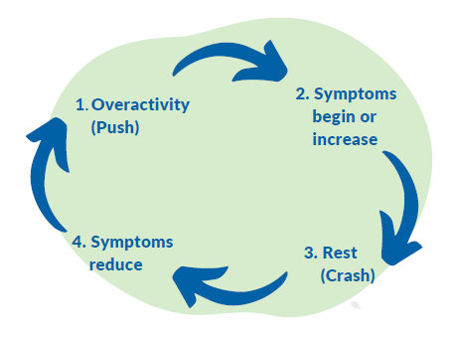

PACING CAN HELP
Pacing is a skill to help you to manage your energy and expectations so that you experience less post-exertional malaise, and avoid the push/crash cycle. Pacing can also help you to:
- Regain control over your time and be better at planning activity
- Match your activity level to the amount of energy you have
- Reduce the frequency and the severity of fatigue symptoms
- Increase your chance for improvement and recovery

Barriers to pacing

It is important to acknowledge the barriers to pacing and how hard it can be to prioritize your health. Some of these barriers might include: family roles and responsibilities, work, financial stress, and expectations.
Pacing might sound like a simple concept, but it can be very hard to change the way you approach life and activity. You might find it frustrating when you don’t have the energy to do your typical activities. Be kind to yourself as you learn about pacing and try new tools to support your health.
You can learn about self-compassion to help you with pacing in our handout, “Plan: How to manage brain fog.”
We outline ways to get started with pacing in our "Adapt: Adapting your activity and environment" handout.

References

Campbell, B. (2021, November 26). Pacing vs. Push and Crash. ME/CFS & Fibromyalgia Self-Help Program. http://www.cfsselfhelp.org/library/pacing-vs-push-crash
Jason, L. A., Brown, M., Brown, A., Evans, M., Flores, S., Grant-Holler, E., & Sunnquist, M. (2013, January 14). Energy conservation/envelope theory interventions to help patients with myalgic encephalomyelitis/chronic fatigue syndrome. Fatigue : biomedicine, health & behavior. Retrieved November 26, 2021, from https://www.ncbi.nlm.nih.gov/pmc/articles/PMC3596172/
Kos, D., van Eupen, I., Meirte, J., Van Cauwenbergh, D., Moorkens, G., Meeus, M., & Nijs, J. (2015). Activity pacing self-management in Chronic Fatigue Syndrome: A randomized controlled trial. The American Journal of Occupational Therapy, 69(5). https://doi.org/10.5014/ajot.2015.016287
PHSA. (2021, August 26). What we know about post exertional malaise after COVID-19 [Video]. YouTube. http://www.phsa.ca/health-info/post-covid-19-care-recovery
PHSA. (2021, September 27). Fatigue after COVID infection [Video]. YouTube. http://www.phsa.ca/health-info/post-covid-19-care-recovery

